ML+NN Midterms feedback

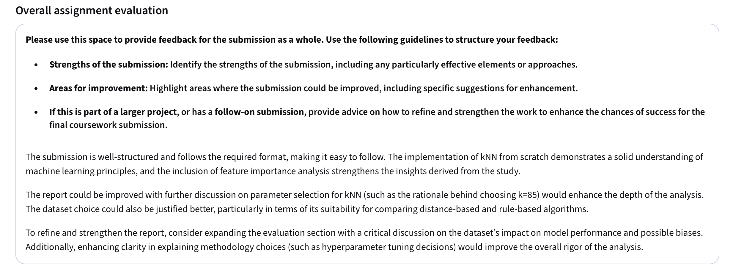

ML+NN Finals feedback
